Arab European Leadership Network in Higher Education ARELEN
A Sub-Organisation of the Association of Arab Universities
is organizing a workshop on:
The Role of Higher Education in
Providing the Relevant Skills Needed for the Digital Age
(Life Skills, Digital Skills, & Leadership Skills)

Come Join Us on in Achieving Excellence Together!
December 18th and the 19th of December 2019

Global Experts within the Higher Educational Field will lead a number of:
The Event will take place in Alexandria, Egypt
(1) Keynote Speeches

(2) Success Stories

(3) Team-based Exercises & Discussions

One of the most popular and majestic touristic destinations
At the Arab Academy for Science, Technology and Maritime Transport, main campus

Topics Presented:
  - Online Education as an Increasingly Accepted Option
  - Improving Digital Literacy in Higher Education
  - Essentials of Leading Change in Higher Education
  - Teaching Life Skills in Leading Higher Education
  - Encouraging Staff Performance Management

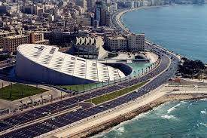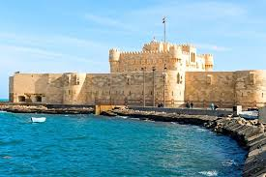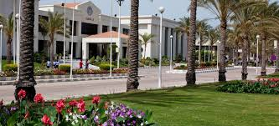
Workshop Registration for Egyptians: $150 – Non-Egyptians: $300
For More Information or to Register contact:
Leadership@aast.edu or Asssec@aaru.edu.jo or WhatsApp: 002001001603618
Accommodation with corporate price can be assisted
The Event Seeks to
Navigate Rapid Change in Higher Education
A Number of Leading Keynote Speakers under One Roof
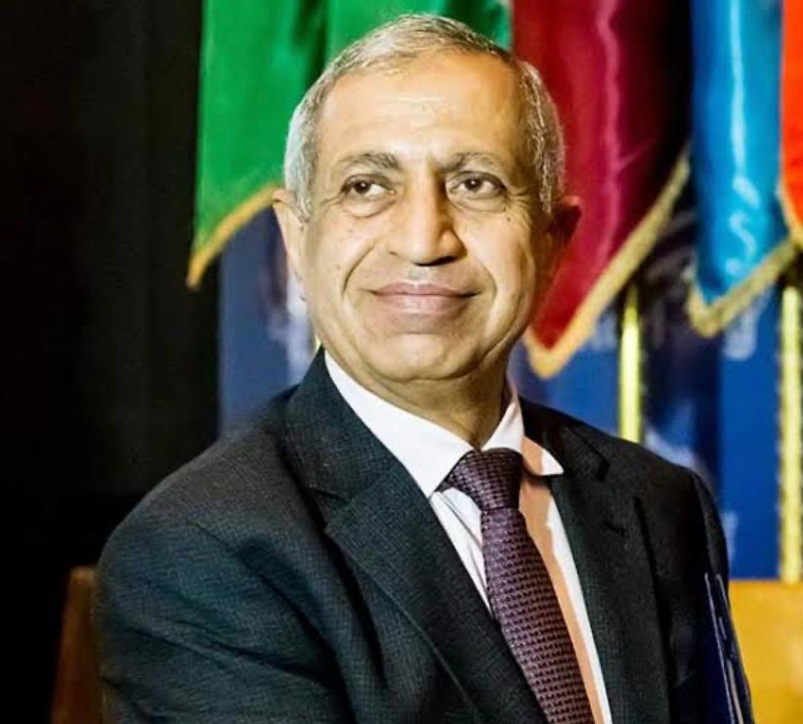  Professor. Ismail Abdel Ghafar Ismail Farag  President of the AASTMT  ARELEN Governance Board |  | 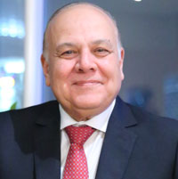  Professor. Amr Ezzat Salama  Secretary General of AArU  ARELEN President
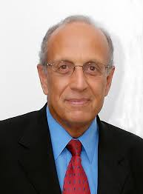  Dr. Mohamed Salem  Former Minister of Communication & Information Technology, Egypt |  | 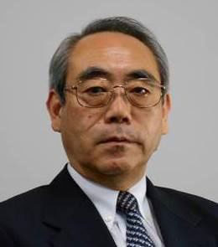  Professor. Masaaki Suzuki  Vice President of International and Regional Affairs – Egypt-Japan University of Science and Technology
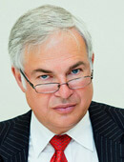  Mr. David Lock  ARELEN Secretary General  Secretary General, Magna Charta Universitatum, Italy |  | 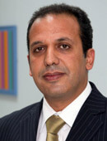  Professor. Mohamed Loutfi  ARELEN Vice- President  Vice Chancellor Special Envoy, Coventry University, UK
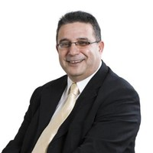  Professor. Ghassan Aouad  President of Applied Science University, Bahrain |  | 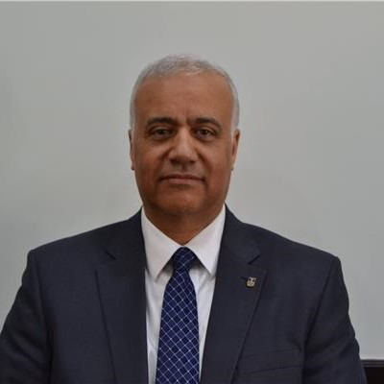  Professor. Essam El Kordi  ARELEN Governance Board  President of Alexandria University, Egypt
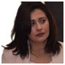  Dr. Hanan Gouda  ARELEN Executive Board  Dean, Arab Institute for Leadership Development, AASTMT | 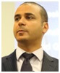  Dr. Nael Alami  ARELEN Executive Board  Provost, Modern University of Business and Science, Lebanon
Registration Form
Workshop Name: The Role of Higher Education in Providing the Relevant Skills Needed for the Digital Age (Life Skills, Digital Skills, & Leadership Skills)
Workshop Dates: 18th and 19th of December 2019
Workshop Venue: AAST Alexandria, Egypt
Organizing Association: AARU & Arab Institute For Leadership Development (AILD)
PLEASE KINDLY FILL IN A SEPARATE REGISTRATION FORM FOR EACH ATTENDEE
Full Name
Person Attending the Event
Affiliation
City, Country
Mobile (With Country code) |  | Email
Would Like Assistance in Accommodation: |  | Number of Nights:  - From: to:
  Yes |  | No
- Note:
Hotel Price will be for: Non-Egyptians: $170 / Egyptians: Single Room 1,200 L.E. Double Room 1,400 L.E.
Payment is made to the Hotel

Workshop Registration for Egyptians: $150 (2,500 L.E.) Non-Egyptians: $300
Payment Method:
Local and Overseas participants may transfer the registration fee directly to the bank Account as below:
Arab Academy for Science, Technology & Maritime Transport
Bank Name: SUEZ CANAL BANK
Bank Address: 60 Al-Horreya Road, Alexandria, Egypt P.O. Box 1767
A/C 2030075641100102
Swift Code: SUCAEGCXALX
- Deadline for registration 10 December 2019

